Daniel 7 – Horns of the Beast

|  |  |  |  |  |  |
| --- | --- | --- | --- | --- | --- |
|  | 4rth beast | 10 horns | crushing | Small horn | 3 horns |
|  |  | **Esuv and it’s territories and/or religion** | |  |  |
| Rashi | Rome (Edom) | 10 emperors till they destroyed the Beis Hamikdash  Julius Caesar  Augustus (31 BCE–14 CE)  Tiberius (14–37 CE)  Caligula (37–41 CE)  Claudius (41–54 CE)  Nero (54–68 CE)  Galba (68–69 CE)  Otho (69 CE)  Aulus Vitellius (69 CE)  Vespasian (69–79 CE) |  | Titus (79–81 CE)  Haughty – I am stronger than Hashem  - destroy our holidays and torah | ? |
| Ramban  Geulah 3, End of Vayishlach | Rome and its religion (as we know from Yitzchak) - Yes kittim is rome, but they were an offshoot from yavan and their own people. Edom were the supporters of the new religion, and supported it until it was taken on by Constantine – Why that religion called daughter of Edom, and targum in eicha (censored)  Rambam – Created the religion much afterwards (possibly at diet)  Explains that the Aluphei of Edom was a “siman libanim” of these ten horns, from Edom to Rome  (See R Bechaya there)  Gra - Rome was an emigration of Edom | | | Entire Religion  Change – switch mashiach switch torah, chutzpah, because ridiculous, yasbir, because never worked, crushed – constantly tried destroying | |
| Ralbag | Rome and the religion, 10 kingdoms (Caesars) until the new Religion was started | | | The Emperor who brought the new religion to everyone (Constantine) – haughty – to say that god went into a womb – the three horns are the three kingdoms that he forced his religion on. Change torah and times refer to the New Testament | |
| Gemara Shevuos 7 | רבא אמר כגון שבור מלכא וקיסר א''ל רב פפא לרבא הי מינייהו עדיף אמר ליה בחורשיא קא אכיל ליה פוק חזי טיבעא דמאן סגי בעלמא דכתיב {דניאל ז-כג} ותאכל כל ארעא ותדושנה ותדקנה א''ר יוחנן זו רומי חייבת שטיבעה יצא בכל העולם כולו | | |  |  |
| Yalkut Shemoni (find source) | Esuv, which destroyed people who started succeeding, which has harmed us more than any other nation | Ten kings all descendants of Esuv |  | Ben Natsur | Mukdin, Koros, Keriros |
| RSG2  (side Peirush) |  |  | Doubled - both the leaders and the army  Ate- our warriors, crushed – our torah, remains even the poor | Titus – see Rashi | Our kingdom, Greece, and Arabia |
| Abarbanal | Rome  (The other prophets did not give prophecies on the fourth) | As rashi | Cruelty, wisdom and Fear  Ate – integrated those who joined the Pax, crushed – those that refused  Ate – Counsels (Senate?)  Feet - army | The Papacy – which Constantine who raised Pope Sylvester  Started as a small horn a nothing of power.  Also used their mouth, fought on a few fronts | (Maybe the first three beasts)  Kings, Senators, Caesars, were overthrown by theological dictatorship.  Or  The first 3 caesars before jc |
|  |  |  |  |  |  |
|  |  |  |  |  |  |
|  |  | **Esuv merged with Yishmael** | |  |  |
| RSG | Aram (Rome) | 10 kingdoms all in one time  Bring R Saadiah Goan’s 10 countries (don’t remember where I saw this) | Doubled, because both Rome and Yishmael  Ate – 1st beis Hamikdash, crushed -2nd, remains, each gen | Yishmael in the Arab lands  - speaking Hashem sent me | Overthrew 3 counties, 2 from Aram (Constantine & Ashkenaz over Italy, and Persia and Eilem who speak Persian, the remaining head being Usegedar that Yishmael took from Bavel, Esfahan, Mesopotamia and all the kingdoms of Brashan) |
|  |  |  |  |  |  |
| Rambam  (Igeres Teiman, beginning) | Rome |  |  | Mo, who “looked like he has mouth and eyes” tried mimicking torah w chutzpah like mannequin, change religion to his, his shabbas his torah ( Rambam writes that islam lies about torah)( 3 (although not related) – those who convert by sword, by forced debate, by trying to cozy up) | |
| Malbim | Rome | 10 toes that ruled everywhere |  | Mohamad- he took 3 kingdoms away – they only fought with power, mo fought with his mouth as well. | |
|  |  |  |  |  | |
|  |  | **Yishmael** | |  | |
| Ibn Ezra  Daas Zekeinim Lech licha) | Yishmael  (As Rome is part of the third kingdom – See Bilaam)  (bring kitim online) | Brasan  Isfahan  Aliman (Sheba)  Mecca (Misha)  Egypt  Africa  Bedouins all over (Yosheiv Ohalos)  Pelishtim - Elmiravtan  Alibrabar (white from cham)  Ethiopians |  | Future near Mashiach  Last King will cause great harm to our people. | The nation coming from the east will overthrow the religion of 3 kingdoms, with their religion. |
| Metsudos | “ | Same but has Chaliman |  | Will be smart, and speak wonders against Hashem, of blasphemy |  |
|  |  |  |  |  |  |
| Possible | Maybe recent events |  |  |  |  |

Where is Yishmael? Ramban – only kingdoms that pour from one to another, only those that get their power from subjugating jews, Maharal, got their power from Hashem’s blessing to Avraham, rsg – included, Ibn ezra – 4th beast

Discuss pure destruction

**(מהרל נר מצוה) אמנם מלכות הרביעית**, מפני שרואה עצמה שהיא כל ואין זולתו, ולכך היא רוצה שלא יהיה נמצא אחר*, ולכך הוא משחית הכל, ואין זה רק השחתה. ולכך ראה דניאל את החיה הזאת שיש לה שנים של ברזל )[דניאל ז, ז](/Daniel.7.7)), כי הברזל הוא משחית ומקצץ את הכל, וכמו שבארנו במקומו, שכל ענין מלכות זה רק להשחית. וכמו ששרפה בית אלקינו, והשחיתו אותו. ואין זה רק השחתה, שאין יותר על זה. ואף כי המלכות הראשון גם כן שרפה בית אלקינו, דבר זה מפני שהיו רוצים לכבוש את ישראל תחת ידיהם, ולא היה זה משום השחתה. רק בשביל כי המלכות הזאת רוצה שיהיה מתנשא על הכל, כמו שבארנו למעלה, ולפיכך היו כובשים ישראל. ומפני שהיו רוצים בכבוש גמור*, היו כובשים ושורפים את הכל. אבל מלכות הרביעית, שכבר היו תחת ידיהם מקודם, ועם כי מרדו בהם בדבר* קטון כמו שידוע, מכל מקום בודאי היו תחת ידיהם ורשותם. ולא היה דבר זה רק להשחיתם, ומצאו עילה להשחית אותם.

New details – feet copper, was given ability to conquer the jewish people

1. According to Rashi – it must be a while, ibn Ezra- right away  
   Rashi - the fire of Yaakov, rsg – Fire of the Kivshan
2. Rashi - Carah – dig inside its case, Rsg – crah – nachri – estranged, or my spirit almost left, or sleep  
   rashi - malachim are stationary

24. small horn: Rashi, Ibn Ezra – relatively right away; Rambam, Ramban, RSG – during the process. Either way the other horns were still destructive. (Malbim – the small horn took the place of three horns, and there were three splits in that horn)

25. Explain that we will go in depth on what this means towards next week and towards the end  
 RSG – Yom Nakam Bilibi

28. If little was added, Daniel must have guarded what he did not write? Or that they would conquer the Jews and given permission over them.

Maharal – Al Pni Tahom – foruth galus – Power (of majesty, hedonism and intellect)

How much did Daniel Know at that point (Abarbanel – entire Roman story)

Rambam (Igeres Teiman) Shuvu shuva hashulamis shuva shuva – 4 gulius also Mishma Duma Massa

**There is No Place Like Home – Abie Rotenberg**

You had searched so long, for the answers and the proof,

And they said you'll find it here, with promises of truth.

But the long white robes, and the chanting in the streets,

It left you cold, your soul still had to seek.

What you're looking for, is right there at your door,

Believe me when I tell you friend, you couldn't ask for more.

What your heart has known, is that there is no place like home,

So come on back, oh you'll never be alone.

And when the others came so gently, as peaceful as a dove,

They stirred something inside of you, they only spoke of love.

But what your mind cried out "What of history, the hatred to my race",

And you knew then, you still had not found your place.

…

Despairing and confused, you traveled far and wide,

But you passed through one small country, where you started feeling pride.

So you found a place to study, what you thought was ancient law,

And you wished you learned about it all before.

Now you can stand up straight and tall, because you're where you want to be

No one had it, strong as steel, your faith has set you free.

And as you gaze up at that simple wall, your hand upon a stone,

You can say the journey's over, I am home.

…

What you're looking for, is right there at your door,

Believe me when I tell you friend, you couldn't ask for more.

What your heart has known, is that there is no place like home,

So come on back, oh you'll never be alone.

<https://www.youtube.com/watch?v=0nKuqipUSFg>

End with medrash about Yosef that we started with

מֵעוֹלָם הָיִיתָ יִשְׁעִי, כְּבוֹדִי וּמֵרִים רֹאשִׁי.

שְׁמַע נָא קוֹל שַׁוְעִי, מַלְכִּי אֱלֹ-הַי קְדוֹשִׁי.

הַעֲבֵר חֶטְאִי וּפִשְׁעִי, גַּם בְּגָלוּת הָרְבִיעִי.

חַזֵּק יִשְׂרָאֵל, וְתַכְנִיעַ יִשְׁמָעֵאל, וּמֵאֱדוֹם תִּפְדֶה נַפְשִׁי.

יִשְֹרָאֵל נוֹשַׁע בַּה', תְּשׁוּעַת עוֹלָמִים. גַּם־הַיּוֹם יִוָּשְׁעוּ מִפִּיךָ, שׁוֹכֵן מְרוֹמִים. כִּי אַתָּה רַב־סְלִיחוֹת וּבַעַל הָרַחֲמִים:

Israel, that is delivered by Adonoy with eternal deliverance, even this day may they be delivered [by decree] from Your mouth, You Who dwell on high! for You are magnanimous to pardon and the Lord of compassion. ....

יִוָּשְׁעוּ לְעֵין כֹּל וְאַל־יִמְשְׁלוּ בָם רְשָׁעִים. כַּלֵּה שֵׂעִיר וְחוֹתְנוֹ, וְיַעֲלוּ לְצִיּוֹן מוֹשִׁיעִים. כִּי אַתָּה רַב־סְלִיחוֹת וּבַעַל הָרַחֲמִים:

Deliver them within sight of all, and let them not be ruled by the wicked. Destroy the tyranny of Seir [Esau] and his father-in-law [Ishmael], and let the deliverers go up to Zion, for You are magnanimous to pardon and the Lord of compassion.

Talmud ~200-500

Rav Saadia Gaon 882-942

Rashi 1040-1105

Ibn Ezra 1089-1164

Rambam 1138-1204

Ramban – 1194-1270

Ralbag – 1288-1344

Abarbanel – 1445-1530

Metsudos – 1687-1769)

Malbim – 1809-1879

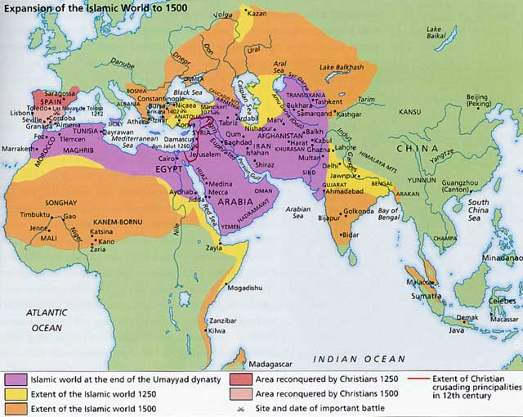

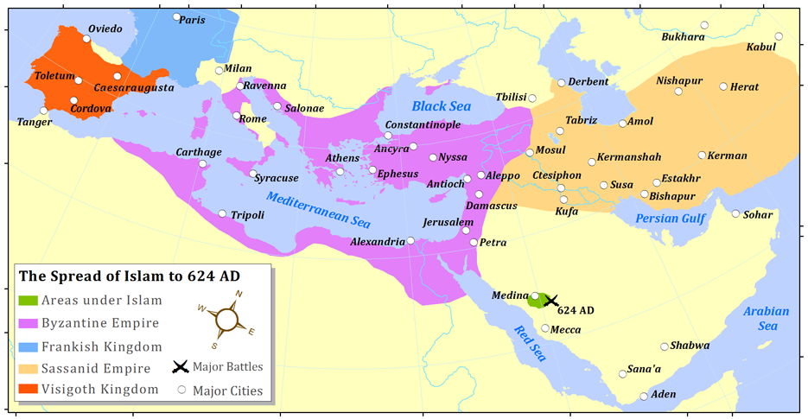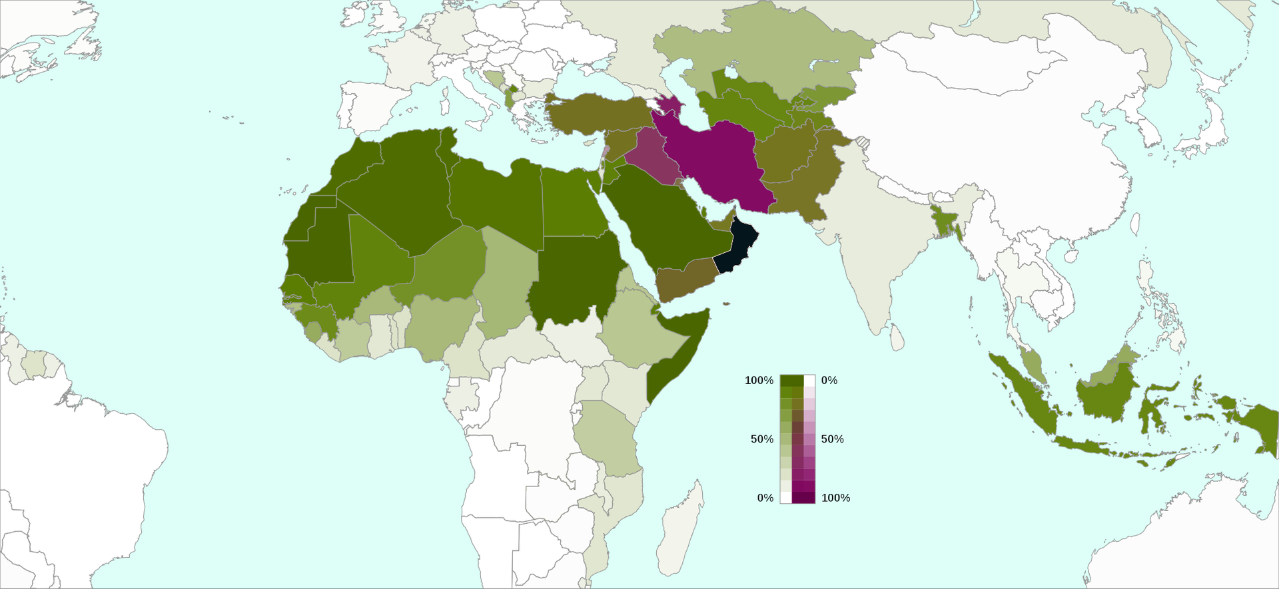

Current World Religion map: <https://ny.pbslearningmedia.org/resource/sj14-soc-religmap/world-religions-map/>

The spread of religion: <https://www.youtube.com/watch?v=AvFl6UBZLv4>

The spread of the religion of Edom: <https://www.youtube.com/watch?v=BJ0dZhHccfU>

Rome and her religion: <https://www.youtube.com/watch?v=9Gp-_ZsUagc>

Roman Empire – year by year: <https://www.youtube.com/watch?v=w5zYpWcz1-E>

